To begin this lab, I first made sure my Windows Server 2022 Domain Controller VM and Windows 10 Client VM were configured correctly so they can be reused in later labs. Below are the settings I verified for each machine. The adapter 1 was set as the internal network , previously adapter 1 was not set as the internal network as seen in the lab 0 documentation

Windows Server 2022 VM Settings (DC01)
- Name: Win22 server
- OS: Windows Server 2022
- CPU: 2
- RAM: 4GB
- Storage: 50GB
- Network: Internal Network – 192.168.10.0/24
- NIC: intent / internal network

Windows 10 Client VM Settings (CLIENT01)
- Name: WIN10-CLIENT1
- OS: Windows 10
- CPU: 2
- RAM: 4GB
- Storage: 40GB
- Network: Internal Network – 192.168.10.0/24
- NIC intent / internal network

Next, I configured Active Directory Domain Services and promoted my server to a Domain Controller. This created the foundation for the entire environment.

Installed AD DS
Server Manager → Add Roles and Features → Active Directory Domain Services

Promoted to Domain Controller
- Selected: Add a new forest
- Domain name: lab.local
- Left DNS option enabled
- Set a Directory Services Restore Mode password
- Completed installation and restarted
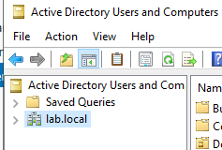

Then, I created the core directory structure used by real organizations

Created Organizational Units
In Active Directory Users and Computers:
I created the following OUs to organize the environment:
- IT
- HR
- Finance
- Sales
- Executives

Next, I created the user accounts for the environment.
I created test users, one for each department, and placed them in their corresponding OUs:
- It clerk
- Hr clerk
- Finance clerk
- Sales clerk
I created each user with:
ADUC → Right-click OU → New → User
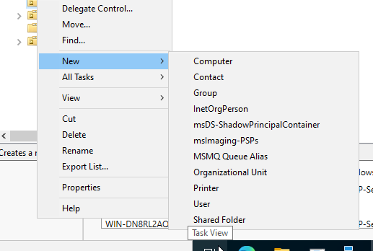

After setting up users, I created security groups for access control.
Inside each department’s OU, I created one security group:
- IT Users
- HR Users
- Finance Users
- Sales Users
- Executive Clerk
I then added each user to their correct group.
Example:it.user → added IT clerk to to IT-Users
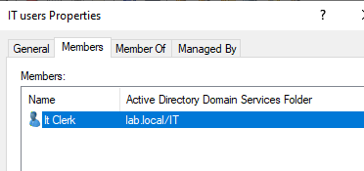
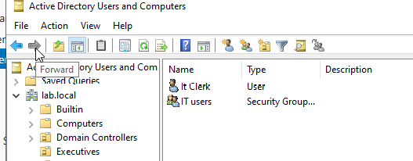

Next, I configured DNS for the domain
Inside DNS Manager, I verified that the DC automatically created:
- Forward Lookup Zone:lab.local
- A record for the machine → 192.168.10.10
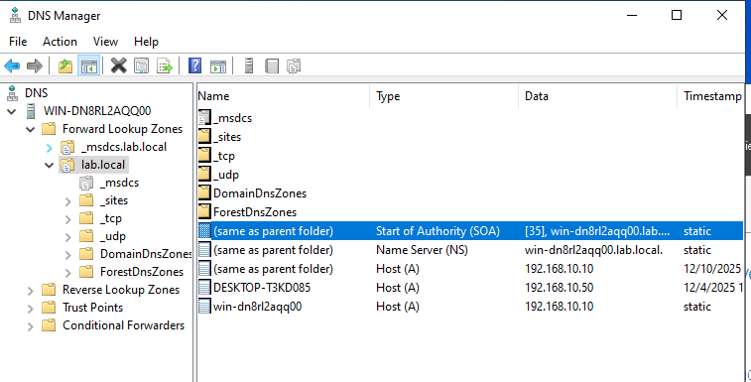

I then configured DHCP on the Domain Controller.
In the DHCP console, I created a new IPv4 scope:
- Scope Range: 192.168.10.50 – 192.168.10.200
- Subnet Mask: 255.255.255.0
- Router: 192.168.10.1
- DNS Server: 192.168.10.10 (the domain controller)
After activation, the scope handed out IP addresses to the client successfully.
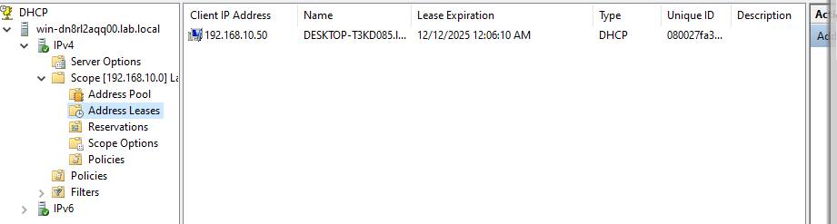

Once DHCP and DNS were set, I domain-joined my Windows client.
On CLIENT01:
Settings → System → About → Rename this PC (Advanced) → Join a Domain
- Domain: mycorp.local
- Restarted and confirmed domain join
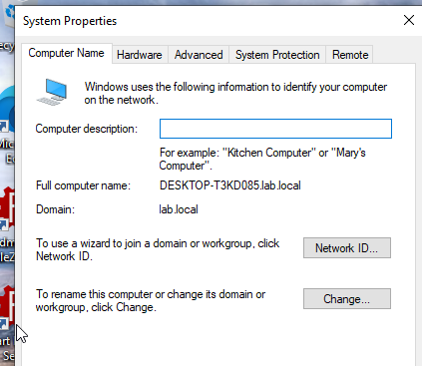

Then, I created and applied Group Policies for the organization.
In Group Policy Management:
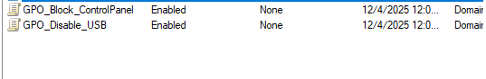
- Disable Usb drives
- Disable access to control Panel

Next, I tested DNS and connectivity to ensure domain operations were healthy.

Ping Domain Controller
ping 192.168.10.10
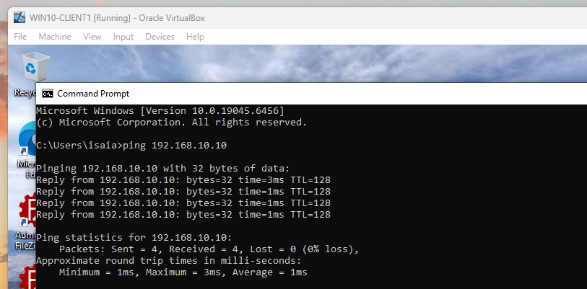

Check DNS Resolution
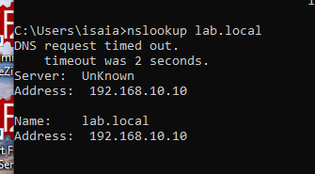
nslookup mycorp.local

Confirm DHCP Leaseall

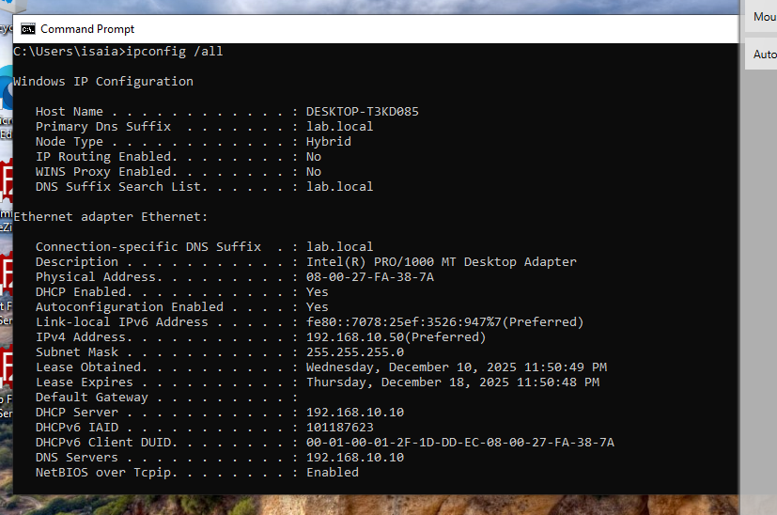
Finally, I documented the troubleshooting steps I encountered.

Issue: Devices could not communicate
- Cause: DNS server not assigned on client , machines also cannot ping eachother
- Fix: Updated vm network settings
- Verification: ping was successful

